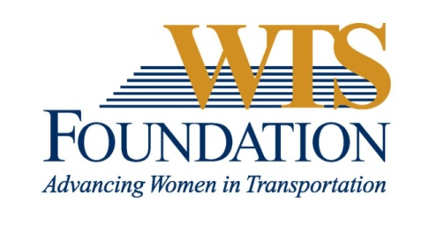

WTS Transportation YOU High School Scholarship

WTS fosters the development of women and girls in the transportation field by encouraging bright new professionals and students to undertake careers in the area of transportation. One way it does this is by awarding the WTS Transportation YOU High School Scholarship to girls pursuing high school studies in science, technology, engineering, and math.
Transportation YOU is a hands-on, interactive, mentoring program that offers young girls ages 13-18 an introduction to a wide variety of transportation careers. Through the Transportation YOU program and this scholarship, WTS chapters work to make a difference in the lives of young girls by offering opportunities and activities that will spark their interest in all modes of transportation and encourage them to take courses in math, science, and technology, which are the stepping stones to exciting careers that can change the face of the transportation industry.
The WTS Transportation YOU High School Scholarship is $1,000. The minimum criteria for selection are:
- Open to all women
- GPA of 3.0 or higher.
- Current resident of Oregon or Southwest Washington
b. Currently a high school Senior studying math, science, and technology.
d. Considering a college degree in a transportation-related field

Scholarships are competitive and based on the applicant's specific transportation career goals; leadership, especially related to transportation; academic record; transportation-related activities or job skills; writing skills; and letters of recommendation. Minority candidates are encouraged to apply. Portland chapter awards will be presented at the December Winter Gala; attendance at the awards dinner is strongly recommended.

How to Apply
The completed application must be submitted electronically as a typed Word document. Transcripts and letters of recommendation can be provided either electronically or via US postal mail; see below.
All components of application must be received no later than 7 pm Wed. October 21, 2015.
Incomplete or late applications will not be considered.
Application materials are not returned to applicants.

 | Submit Electronically - required | Paper Copy
Address to submit to: | gladhill42@msn.com  Subject Line: WTS scholarship application for your name, scholarship name | Kristie Gladhill  3190 SW 66th Ave  Portland, OR 97225
Application | Typing your name in the signature space will be considered an electronic signature.  Electronic Word file is REQUIRED. | N/A
Transcript(s) | Official, certified electronic transcript must be emailed directly from school to email address above. | Can provide official copy, in sealed envelope.
Letter of recommendation | Must be emailed directly from person making recommendation to email address above. | N/A

WTS Portland Chapter Transportation YOU High School Scholarship Application

Personal Information
Name
Last, First, Middle
Email address
Telephone
Current Address
Street
City, State, Zip
Permanent Address
Street
City, State, Zip

II. Educational Background
Current High School
City, State
Expected date of graduation
Area of concentration
Degree to be received (not required in HS)
Grade point average (GPA)
(Minimum GPA of 3.0 required. Attach official copy of transcript to application.)
Professional or school affiliations (list any school, professional or community activities you have participated in. Include offices held and awards received. Attach additional sheets, if necessary.)

III. Recommendation: Letter of recommendation by a teacher, counselor, or principal must accompany your application.

IV. Personal Statement: A statement about your goals to pursue studies in STEM areas (science, technology, engineering, or math) while in college and why you think that you should receive the scholarship award. Statement should not exceed 500 words. Please attach as a word document to application form.

Signature_____________________________________Date___________________

Parent/Guardian Signature_____________________________________Date___________________

