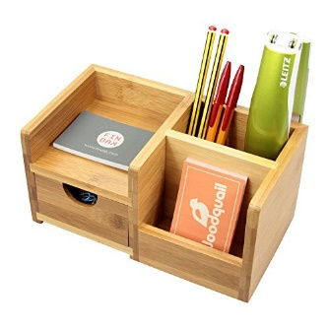
Desk Organizer Parts List
Qty | Part Name | Part Size  T” x W” x L” | Check

